Sidewalk Upkeep Examples

City Of Meriden
Planning Division

February, 2014
Christopher McGoldrick
This document details a rating scale developed for use in conjunction with the “Meriden Comprehensive Sidewalk Analysis and Strategy Report”. It provides a brief explanation and photo example for various material types discussed in the report. It is intended to be attached to the back of the report for ease of reference.

The following examples show sidewalks with their respective condition. The rating scale translates a condition adjective to a numerical scale of from 0-3. The attributes follow rough guidelines to determine the condition. The scale is represented as follows:
Good: 3 (No obvious flaws)
Fair: 2 (Cracks and some misalignment)
Poor: 1 (Portions missing, severe wear, or severe misalignment)
Very Poor: 0 (Severe damage, hazardous conditions)

Examples:
Brick “Good” (3)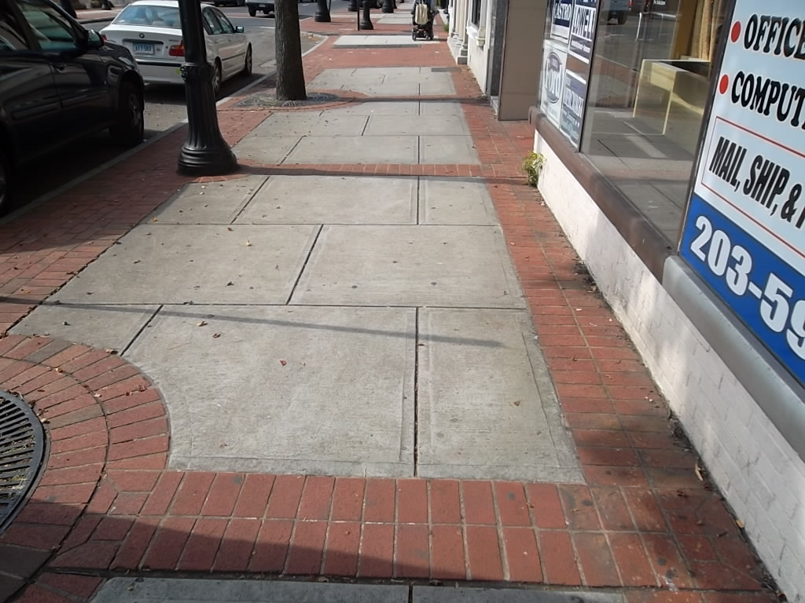Portland Cement/Concrete “Good” (3)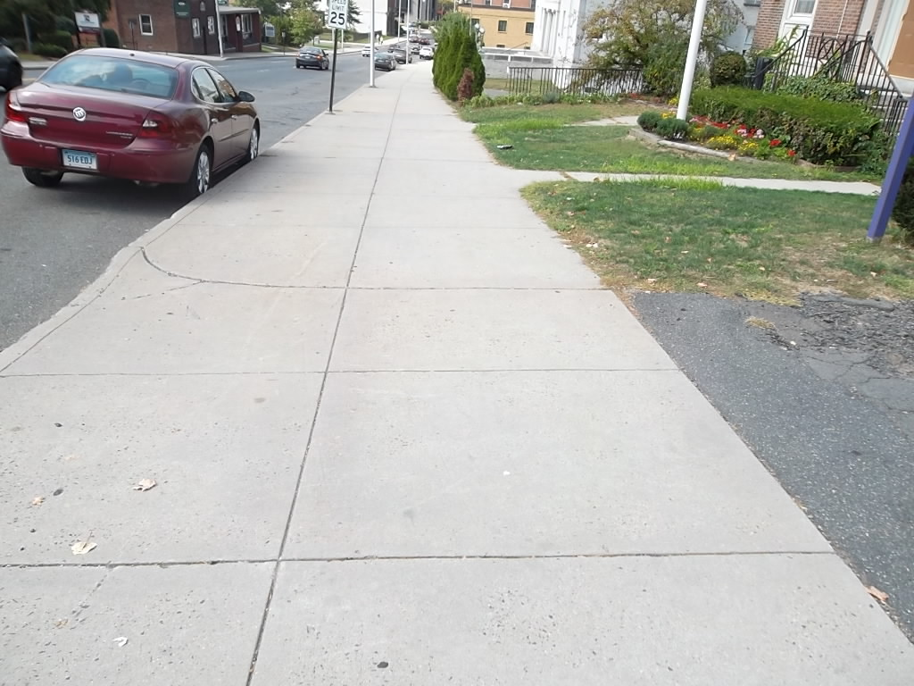
Asphalt “Good” (3)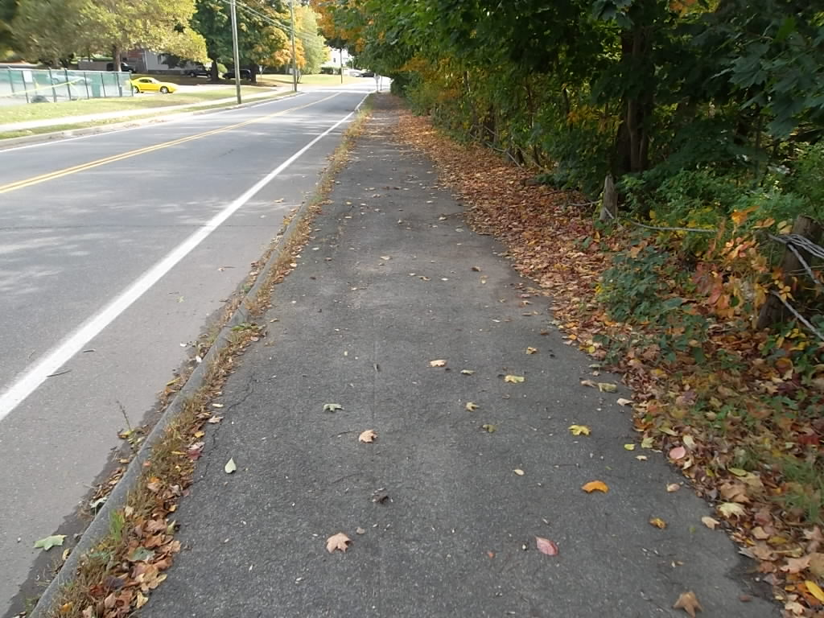 Portland Cement/Concrete “Fair” (2)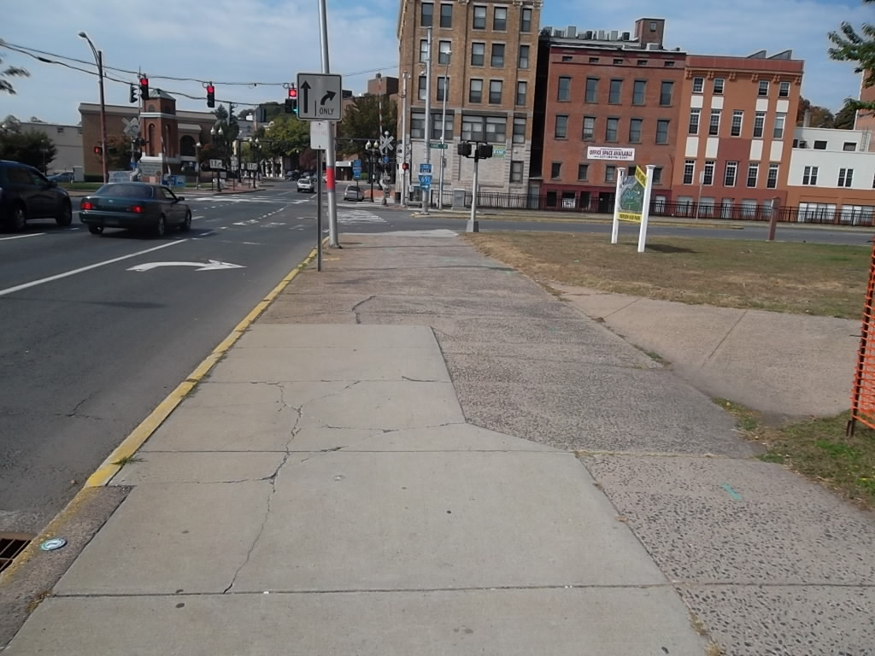
Asphalt “Fair” (2)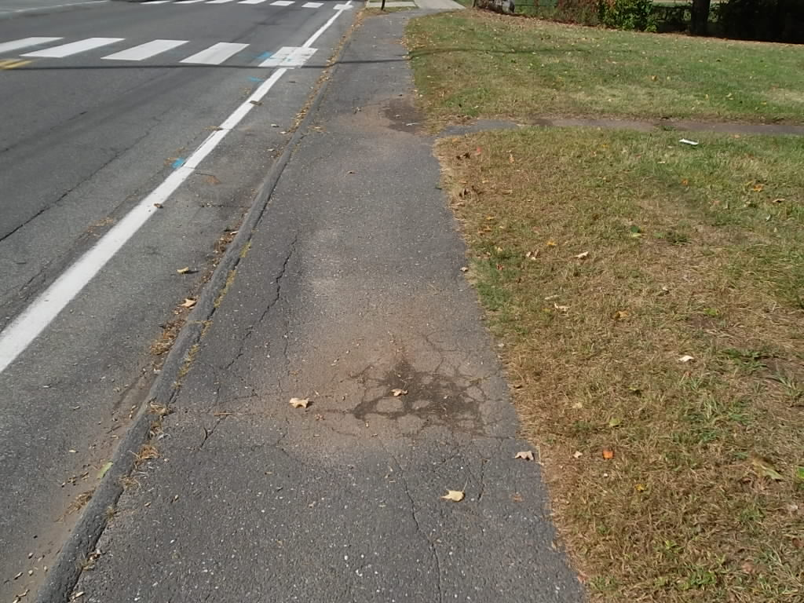
Portland Cement/Concrete “Poor” (1)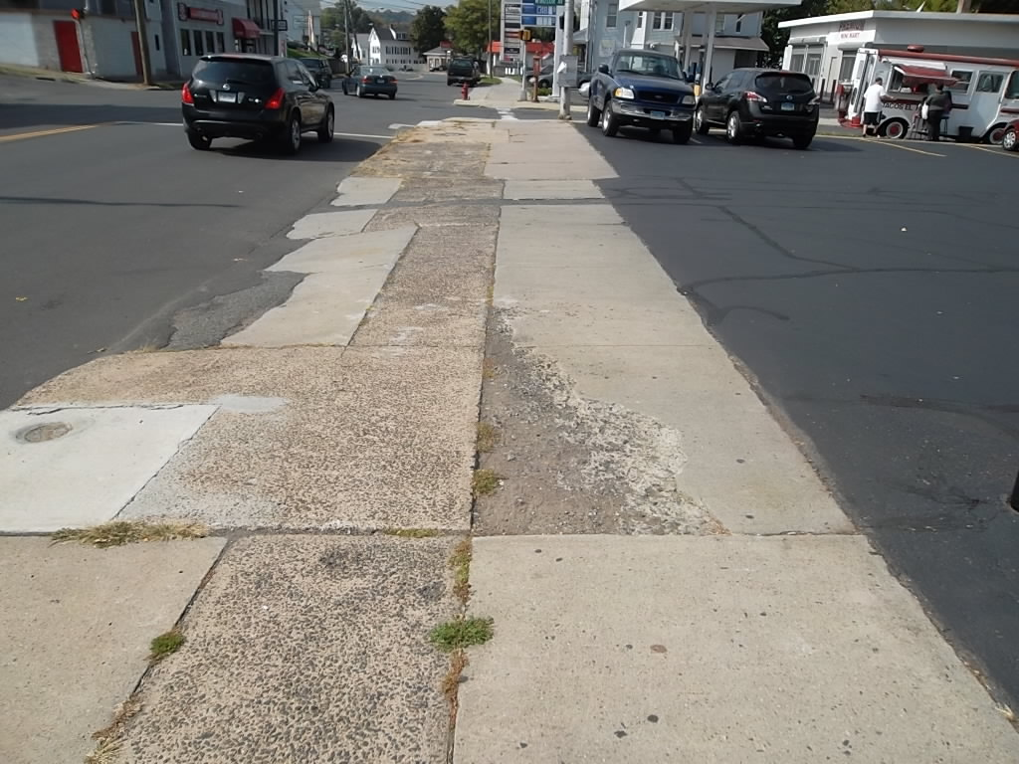

Asphalt “Poor” (1)
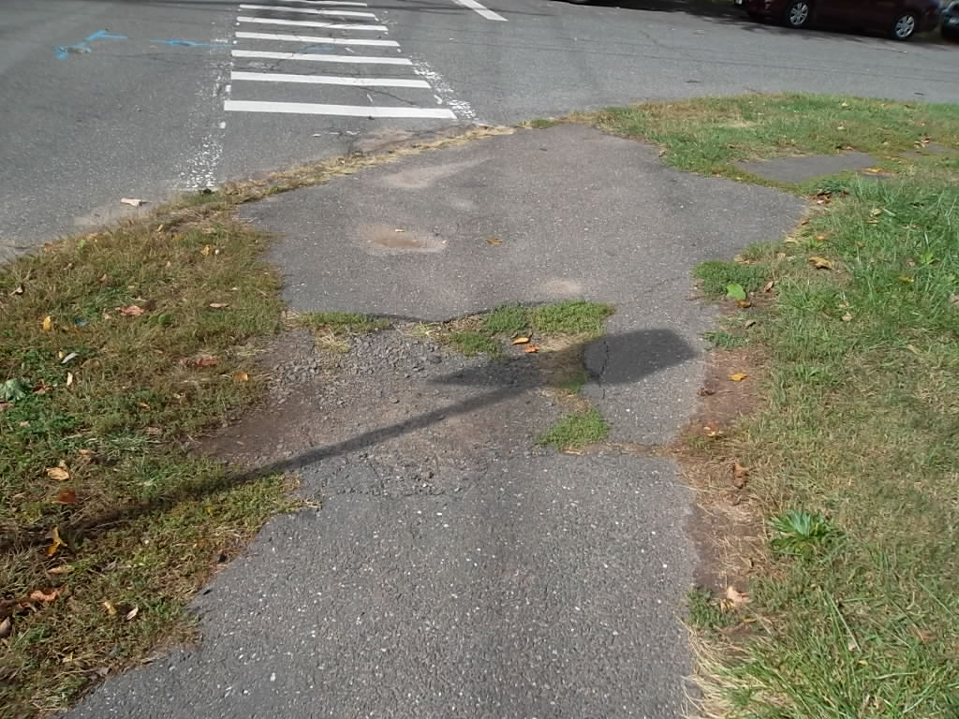

Slate “Poor” (1)
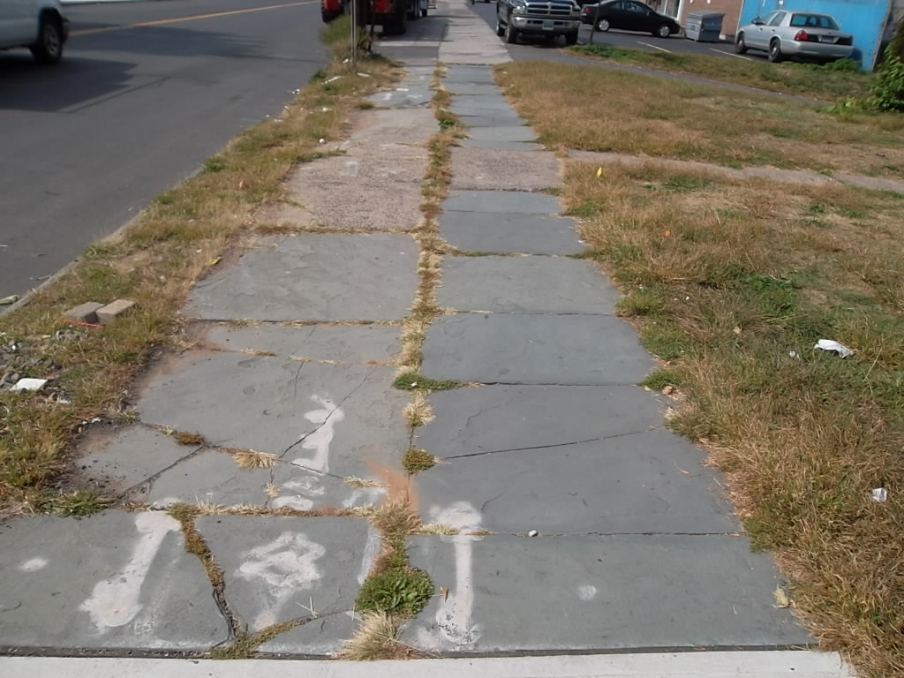

Portland Cement/Concrete “Very Poor” (0)
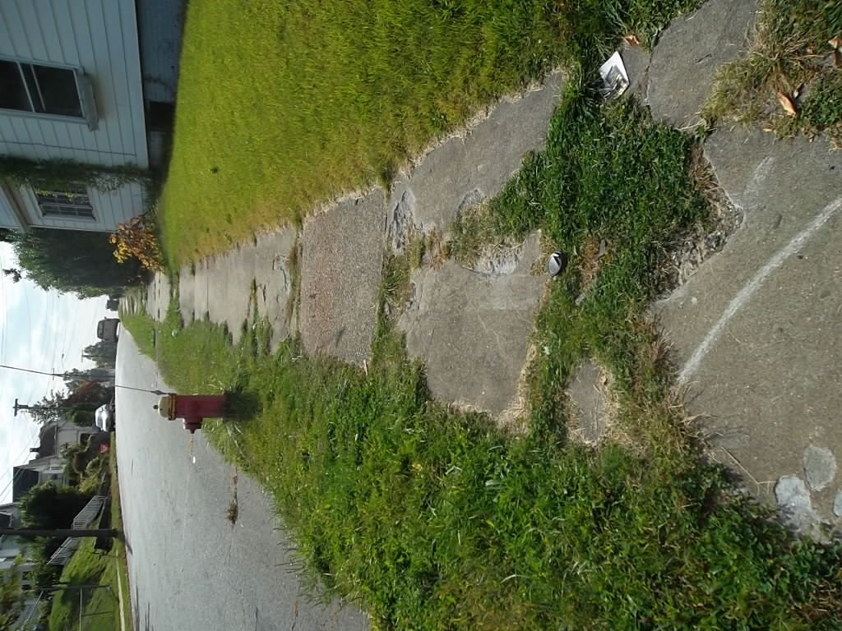
Asphalt “Very Poor” (0)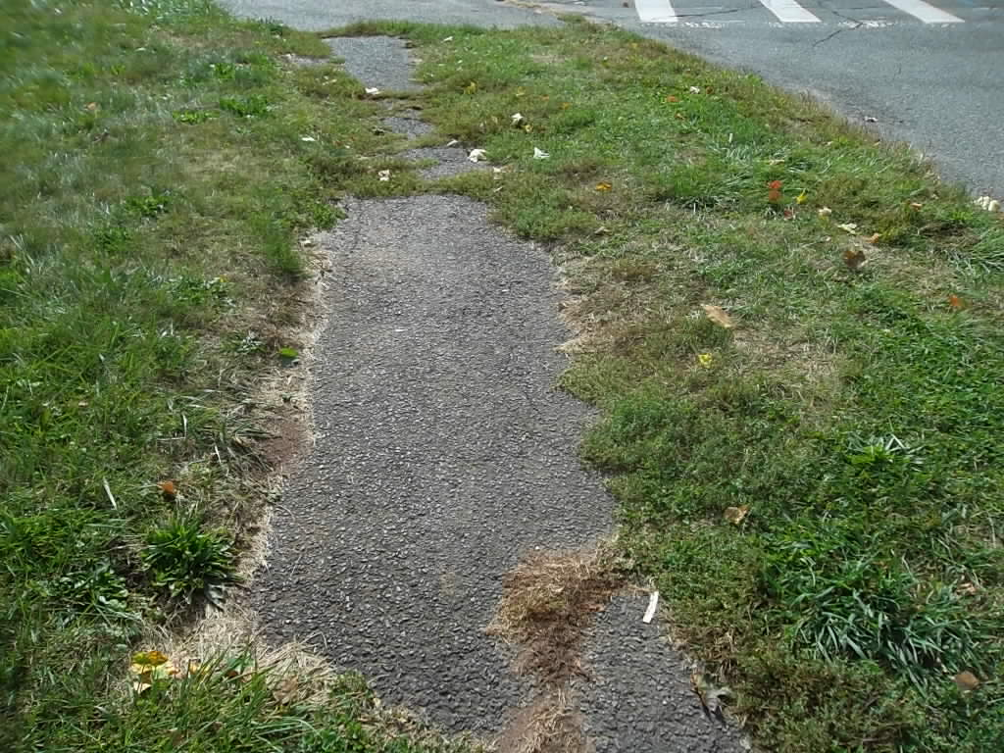

Slate “Very Poor” (0)
