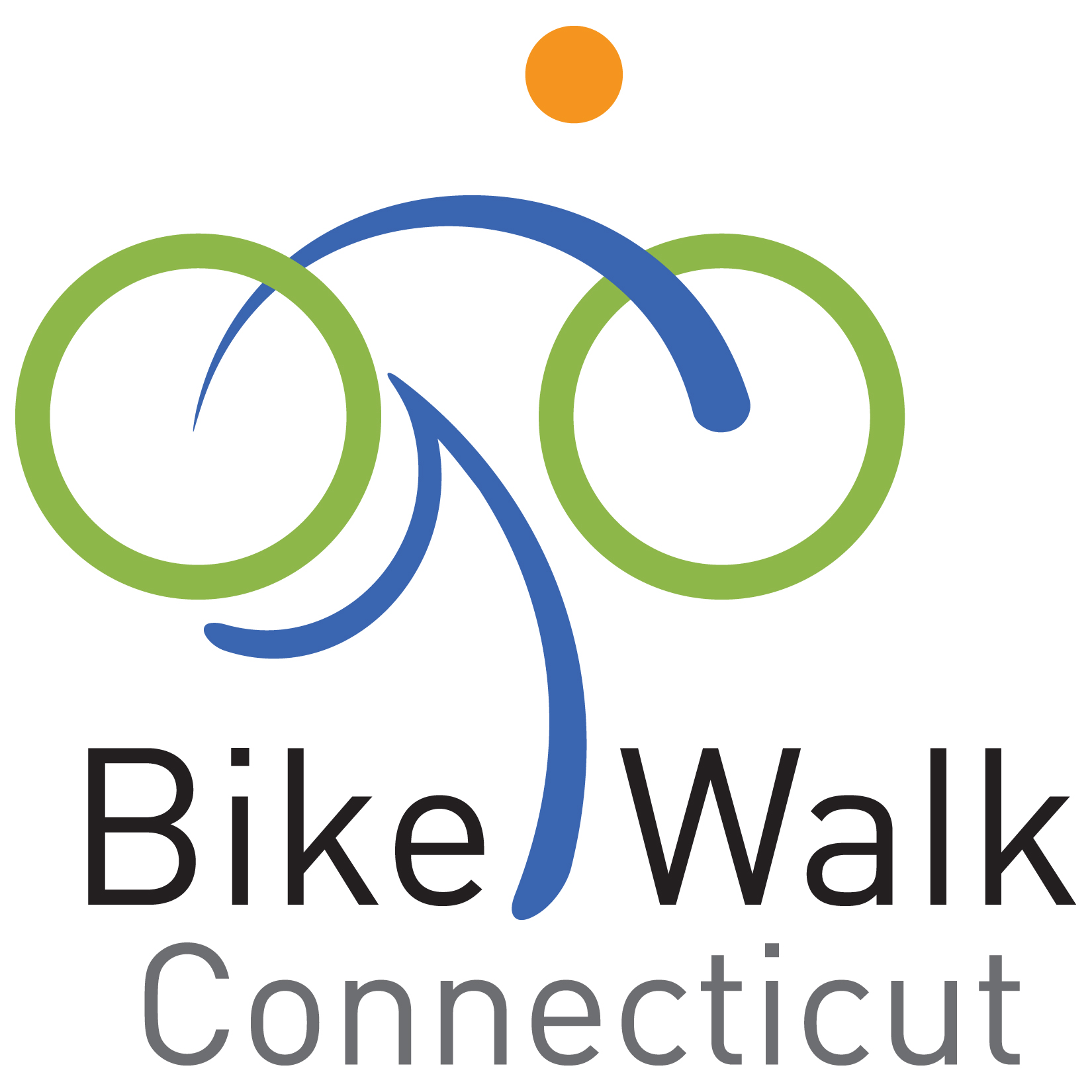

Strategic Plan

JANUARY 2012

Table of Contents

A. | Introduction | p.3
B. | Mission and Vision | p.3
C. | History | p.3-4
D. | Organizational Development | p.4-6
E. | Advocacy | p.7
F. | Education | p.8-9
G. | Events | p.9
H. | Monitoring the plan | p.10

A. Introduction

In six short years, the 501(c)(3) nonprofit Bike Walk Connecticut (formerly the Central Connecticut Bicycle Alliance), has carved out an important place and role in Connecticut's non-motorized transportation advocacy efforts. Since its founding, excellent progress has been achieved through the work of many members and volunteers. As Bike Walk Connecticut solidifies its new position as a statewide advocacy group, and moves from an all-volunteer to a staffed organization, this strategic plan will provide a structure and guidance for the next stage of development.

B. Mission and Vision

Mission Statement
Bike Walk Connecticut is changing the culture of transportation through advocacy and education to make bicycling safe, feasible, and attractive for a healthier, cleaner Connecticut.

Vision
Throughout the country, communities have discovered that investments in bicycle and pedestrian facilities can be important economic drivers. They improve community livability (and property values) and create attractions for visitors. In addition, it has been shown in many areas of our country that when people can bike and walk safely, large numbers of people do bike and walk to work, and bike and walk for errands, and for recreation. Bicycling and walking are part of the solution to many of our society’s problems: the obesity epidemic, traffic congestion, and air pollution.

Bike Walk Connecticut’s vision is for a Connecticut where bicycling and walking are safe, feasible, and attractive, and Connecticut is healthier and cleaner as a result.

C. HISTORY

Formed in early 2005, Bike Walk Connecticut (formerly Central Connecticut Bicycle Alliance) grew out of the activities of the Capitol Region Bike to Work Committee, a project of the Capitol Regional Council of Governments (CRCOG). CRCOG, as part of its bicycle and pedestrian planning capacity for the Capitol Region, initiated the Bike to Work program to promote bicycling as a form of transportation in 2000. The organizing committee was a compilation of many different state departments and private non-profits. These founding groups included the Connecticut Departments of Environmental Protection, Public Health, and Transportation, the Connecticut Bicycle Coalition (CBC), and All Aboard!.

After four years the program expanded to the point where organizing the Bike to Work events outgrew the ability of CRCOG staff to support those activities, and at the same time, the Bike to Work Committee was growing increasingly interested in broader goals of bicycle advocacy and education. Thus was CCBA born with a mission to promote bicycle safety, educate bicyclists and drivers about the rules of the road, and promote bicycle facilities as a way to improve the health of area residents and the quality of life. As its initial undertaking, CCBA took over responsibility for the Capitol Region Bike to Work promotion and maintained many of the cooperative relationships with the Connecticut state agencies, non-profit organizations, small businesses, including area bike shops, and downtown corporations that helped found and support Bike to Work.

Over time, the all-volunteer organization began to have an impact – with the passage of a 3 foot passing law in 2008 and a Complete Streets bill in 2009. The group developed a well-regarded and well attended event celebrating biking and walking – the not quite annual Discover Hartford Walking and Biking Tour. With CRCOG providing staff support, the CCBA began to lay the foundations for a comprehensive bicycle education program based upon the League of American Bicyclists smart cycling curriculum, which continues today.

In 2010, with the recognition that much of its work had statewide impact and that the needs and interests of bicyclists and pedestrians are closely aligned, the organization decided to expand its mission and to become Bike Walk Connecticut. Also in that year, the first full time executive director was hired.

D. ORGANIZATIONAL growth and DEVELOPMENT

The following goals and objectives are intended to facilitate a dynamic structure that fully engages the Board in strategic decision-making, including planning for the organization’s sustainable growth and development.

Goal I: implement a governance structure and processes that support a statewide organization, and ensures adequate and ongoing representation of diverse stakeholders

Objective 1: Conduct a governance review to ensure that the Board’s size and structure adequately support its work (i.e. officers, committee structure, term limits, by-laws).
- Review nonprofit board best practices and recommend changes to existing structures as appropriate for advocacy organizations.

Objective 2: Ensure that Board members are engaged in a manner that fully utilizes their skills, interests and abilities and engages them with the work of Bike Walk Connecticut.
      - Develop and implement a process for continuous board development and committee membership.
      - Develop and use a Board Matrix that identifies the skills and types of members needed to guide board recruitment and ensure that the Board is representative of the community it serves.

Objective 3: Ensure tools are in place to support effective board governance.
      - Develop a description of the responsibilities and expectations of individual Board members.
      - Develop and maintain annual Board meeting schedule.
      - Develop and maintain a Board Handbook.

Objective 4: Ensure timely and consistent review of organizational finances, addressing any shortcomings or issues promptly.
- Institute an annual audit or professional review process
- Conduct monthly review of current financial status with full board and/or executive committee.

Objective 5: Ensure that the Board adopts and implements policies and procedures governing the organizational operations and board and staff conduct.
- Develop a personnel policies and procedures document

Goal II: develop a balanced resource development strategy that funds current activities as well as future growth and sustainability

Objective 1: Increase organizational membership in order to ensure that the organization is reaching its constituents and providing a consistent source of revenue.
- Develop and implement an annual membership plan
- Increase net individual membership by 25% annually
- Increase net professional and organization (e.g., bike shops ) memberships by 10% annually
- Increase geographic diversity of the organization’s membership by 20% in each of Connecticut’s eight counties annually

Objective 2: Diversify funding sources to insure organizational stability and sustainability
- Annually develop a funding sources goal and plan.
- Engage board members and staff as full partners in resource development, donor support, and solicitation of gifts.
- Develop and implement an individual donor plan to include yearly appeals, a major donor program, and planned giving capability.
- Identify and apply for appropriate corporate foundation and government grants.
- Develop and implement program revenue opportunities, such as delivery of bike education or other services
- Implement fundraising events that increase visibility and provide revenue that exceeds expenses for each event.

Objective 3: Establish and maintain sufficient reserve funding to ensure organizational continuity
- Establish a reserve fund equal to three to six months of annual expenditures within the next year and six to twelve months within 3-5 years.

Goal III: Ensure that Bike Walk Connecticut has the staff and volunteer capacity to enable the organization to grow and change in response to its operating environment

Objective 1: Create a process for and annually conduct a performance evaluation of the Executive Director and ensure that other organization staff members are evaluated at least annually.

Objective 2: Continue to develop and expand a volunteer management and tracking process.
- Capture and update volunteer information in an organized manner and ensure they are recognized as organization donors.

E. ADVOCACY

Advocacy makes the argument for the cause of more and better biking and walking in Connecticut. We advocate in order to rally public support for, and engage public and private sector decision-makers in, our cause. We advocate before local, state, and federal legislatures and administrative bodies, and through mass and specialized media.

Goal IV: Be the premier source for comprehensive, timely, and accurate information on bicycling and pedestrian issues in Connecticut
Objective 1: Develop a resource/library capability for individuals, organizations, and government agencies that includes best practices, accurate data, and access to experts in bicycling and pedestrian issues.

Objective 2: Foster coordination and communication among existing local organizations in Connecticut that promote walking, running, cycling, or fitness in order to develop and disseminate more comprehensive messaging and information.

Objective 3: Develop a media engagement and awareness building strategy to ensure effective coverage and broad dissemination of state and local issues important to cyclists, pedestrians, and other roadway users
- Develop and deploy mass market photo and video promotions graphically depicting the benefits of more and better bicycling and walking in Connecticut
- Employ branding and advertising tactics to create and deploy effective messaging.
- Create awareness through events and tabling opportunities, using a standard approach.

Goal V: defend and advance the rights and interests of bicyclists and pedestrians to efficiently, safely, and enjoyably travel Connecticut's roadways and trails

Objective 1: With other groups, develop, adopt, and advance an annual legislative agenda at the state level.
Objective 2: Engage Connecticut's communities in local legislation to improve the walking and cycling environment.
Objective 3: Annually, develop and publish position papers on pertinent cycling and walking policy issues.

F. Education

Education encompasses our activities and programs aimed at increasing the skills and understanding of all Connecticut residents to efficiently, enjoyably, and safely travel and share our roadways and trails. This includes specific delivery of bicycle skills education, as well as assisting public and private sector entities in their efforts to increase bicycle and pedestrian awareness and activity among their respective constituencies. Education is a core competency of Bike Walk Connecticut.

Goal VI: educate motorists, cyclists, and pedestrians about how to safely and harmoniously share the road

Objective 1: Encourage and help develop cyclist and pedestrian training programs to better educate these road users how to safely share the road with motorists.

Objective 2: Encourage and help develop driver training programs to better educate drivers how to share the road with bicyclists and pedestrians.
- Work with CTDOT and local governments to raise awareness of “3 foot law”
- Work with CT DMV and drivers’ schools to ensure Connecticut’s drivers are instructed and tested in knowledge of the laws and techniques of sharing the road with bicyclists and pedestrians

Goal VII: Ensure all programs and materials are tailored to the needs of diverse populations.

Objective 1: Translate educational materials for diverse groups wherever possible
Objective 2: Research best practices from other, particularly urban, communities on how to reach diverse audiences with effective messaging.

Goal VIII: Directly deliver bicycle and pedestrian education to a broad range of Connecticut residents

Objective 1: Create and facilitate a schedule and series of Traffic Skills 101 classes throughout the state, targeting 5 sessions per year.
Objective 2: Facilitate the identification and training of League Certified Instructors sufficient to meet and drive the demand for cyclist education classes.

Objective 3: Support the Safe Routes to Schools program in Connecticut by targeting 2-3 schools per year to receive 4th grade Bicycle Education programming.

Objective 4: Secure funding to hire Bike Education Coordinator on full or part-time basis

Goal IX: Conduct an Annual Summit focused on Cycling and Walking Education and Advocacy

G. EVENTS

Events include special, planned and spontaneous bike rides and walks that highlight the fun and camaraderie that result from more and better cycling and walking in or our state. Events include free and fee-based rides and walks and rides and walks that are open to the general public, as well as those that are by invitation.

Goal XI: promote and expand bike/walk everywhere as a year-round opportunity

Objective 1: Plan and host activities during National Bike Month around the state.
Objective 2: Work with community organizations and businesses across Connecticut to develop walking and biking events and promotions throughout the year. Ensure that at least one bike/walk everywhere event occurs at least annually in each of Connecticut's counties
Objective 3: Develop and implement recognition activities and vehicles for "all-year" cyclists and walkers.
Objective 4: Publish and maintain a calendar of Connecticut bicycling and walking events
Objective 5: Present annual special event Bike Rides and Walks, including annual Biking and Walking Tour in Hartford and annual Bike Rally at the Capitol.
Objective 6: Develop bike ride and walk events with targeted individuals and/or targeted communities, such as public officials, business leaders, and community-based organization leaders.

H. Monitoring the Plan

This strategic plan reflects the vision and the collective thinking of the leadership of Bike Walk Connecticut. It is the road map that will help to guide our decision making over the next several years. As we move forward with the implementation of this plan, it will be important to institutionalize the planning process by ensuring that mechanisms are in place to:

- Conduct routine and ongoing monitoring of progress toward stated goals and objectives

- Assess changes in our operating environment that might necessitate changes to the plan.

Goal XII: ensure that progress towards goals and objectives continues to be made and that conditions that might require changes to the Plan are assessed and acted upon in a timely manner

Objective 1: Staff will develop and Board will approve an annual operating plan with benchmarks to measure progress toward goals.

Objective 2: Provide routine and ongoing monitoring of the Plan’s goals and objectives, including a quarterly review by the Board.

Objective 3: Plan and conduct an annual Board/staff retreat to assess progress and the possible need to revisit/redefine goals and objectives.

